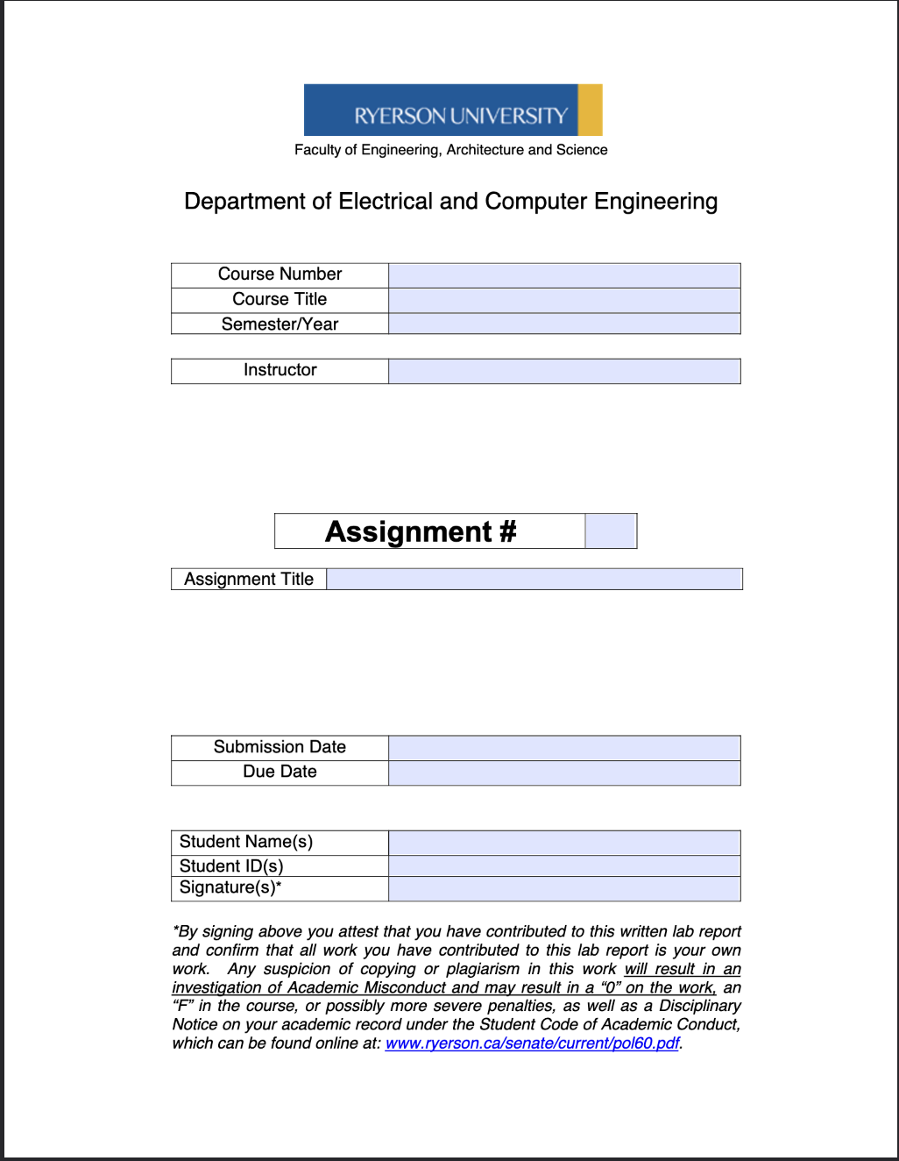
ELE504
Electronic Circuits II
F2024
Dr. Rueda
1
ELE504 Lab Report 1
September 11th, 2024
September 12th, 2024
Shai Mourad/Jason Fu
501170415/501035603
SM/JF

Table of Content
1. Introduction...........................................................................................R2
2. Circuit under Test..................................................................................R2
3. Experimental Results............................................................................R4
4. Conclusions and Remarks.....................................................................R9
5. Appendix…………………………………………...............................R9

Introduction
Within this experiment, op amp circuits will be built to create a further understanding of open loop and positive/negative feedback and their respective effects on output voltage. This lab took place on September 11th, 2024.

Circuit under Test
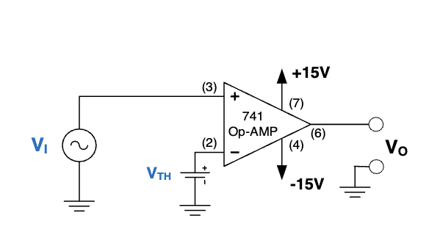
Figure 1 from the Lab Manual.

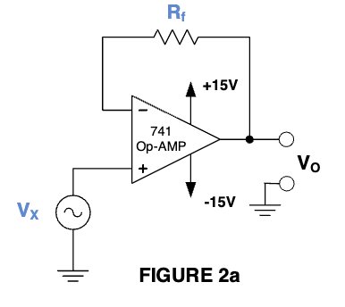

Figure 2a from the Lab Manual.

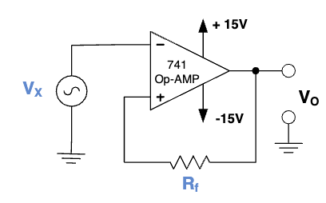
Figure 2b from the Lab Manual.

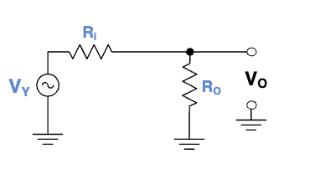
Figure 3a from the Lab Manual.

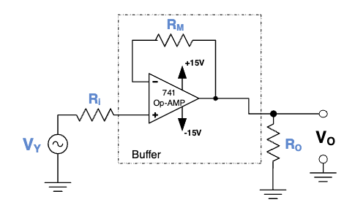
Figure 3b from the Lab Manual.

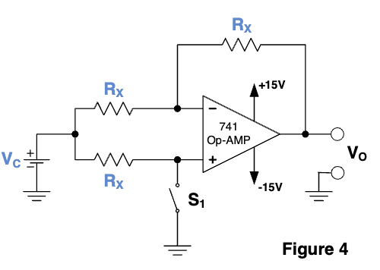

Figure 4 from the Lab Manual.

Experimental Results

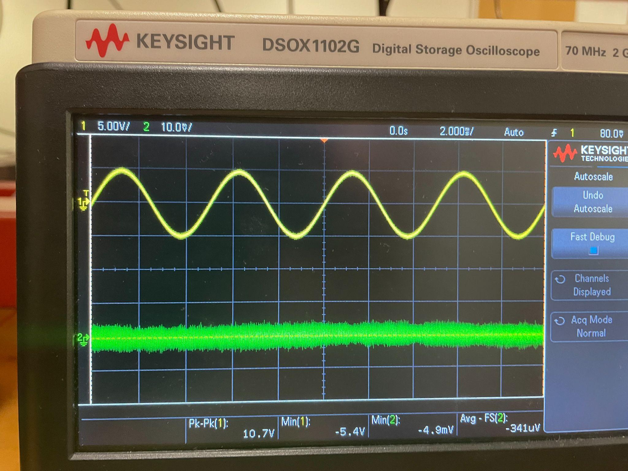
Vi (Yellow) for Figure 1.

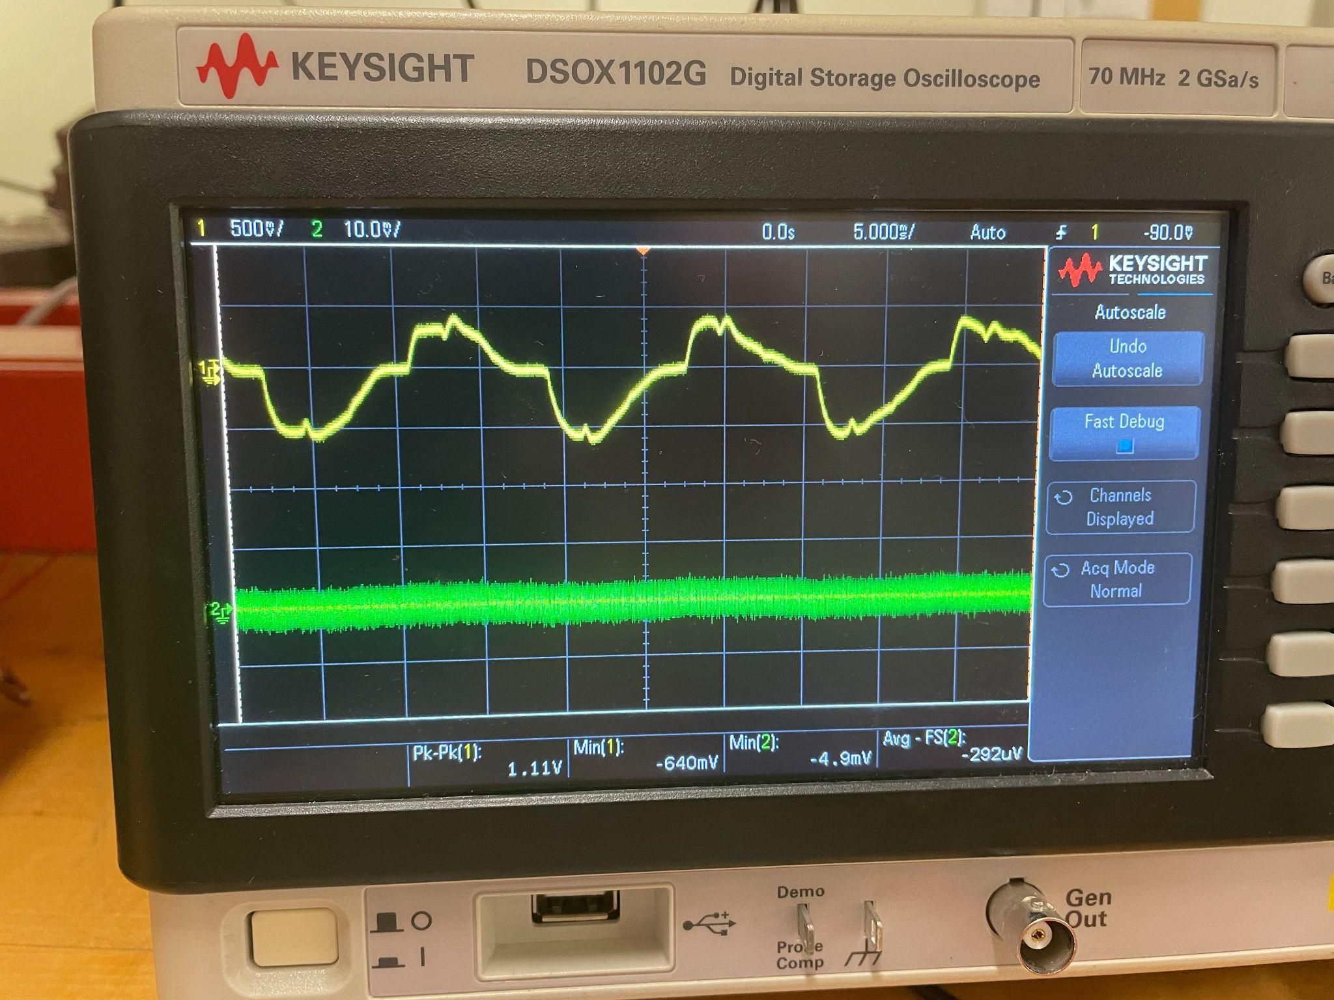
Vo (Yellow) for Figure 1.

 | Vo (prelab Analysis) | Vo(prelab simulations) | Vo(in lab mesurament)
V1<Vth | 14 | 10 | 0.555
V1>Vth | -14 | -10 | -0.555

It can be noticed that the result represents V_{I}(t) < V_{TH} and V_{I}(t) < V_{TH}, as the values fluctuate between positive and negative voltages. There may be a large difference between the pre-lab and in-lab as a result of faulty equipment.

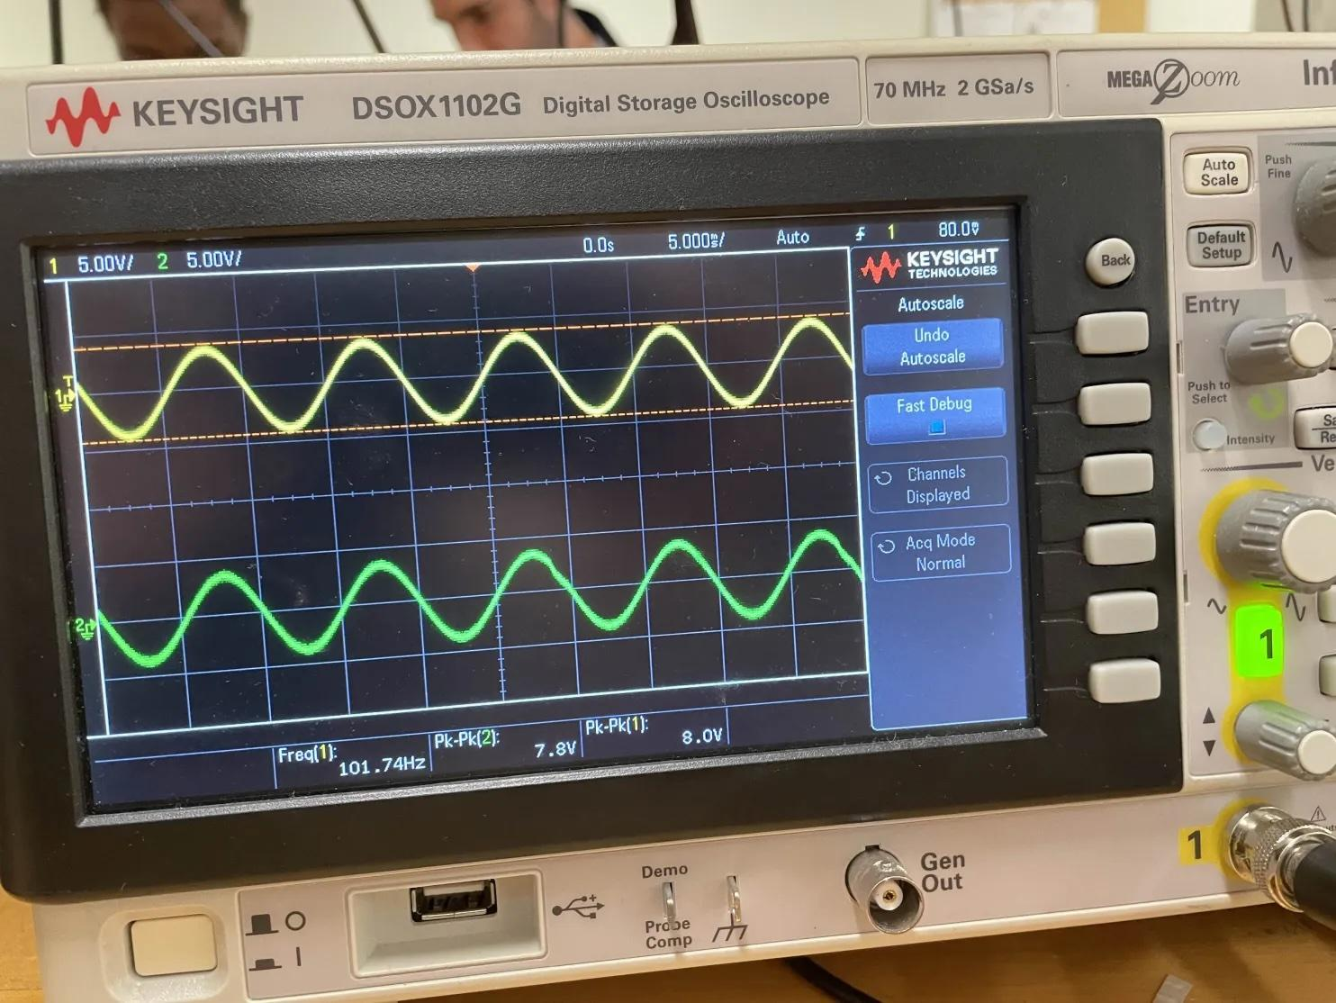
Vi (Yellow) and Vo (Green) for Figure 2a.

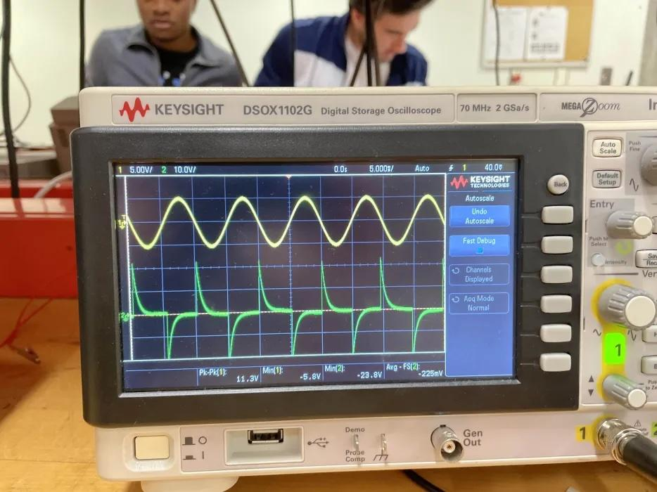
Vi (Yellow) and Vo (Green) for Figure 2b.

In the first graph for Figure 2a, the output graph remains exactly the same. This represents that the negative feedback is working properly, as there is a clear presence of a buffer. For the graph representing 2b, the output has a fluctuation between positive and negative voltages close to L⁺/L⁻ (±14V). The positive feedback loop makes the input operate independently, resulting in the output being L⁺/L⁻. Small discrepancies could result from unaccounted tolerances within the circuit.

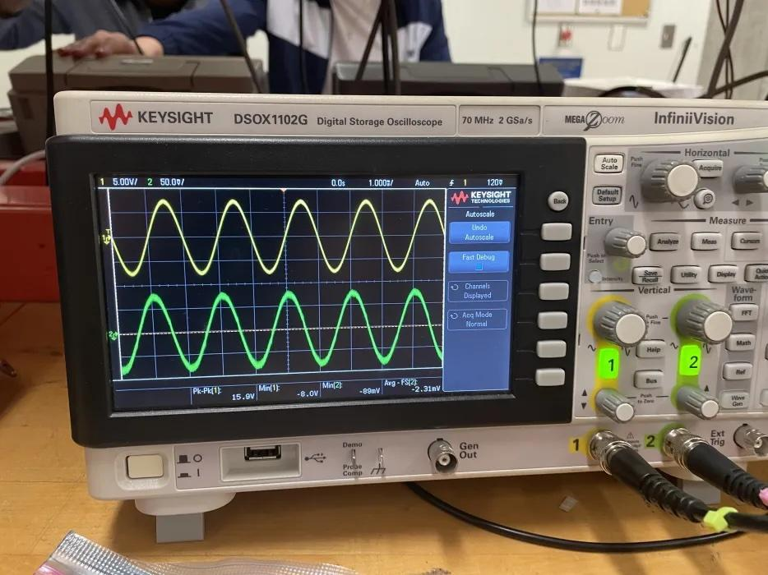
Vi (Yellow) and Vo (Green) for Figure 3a.

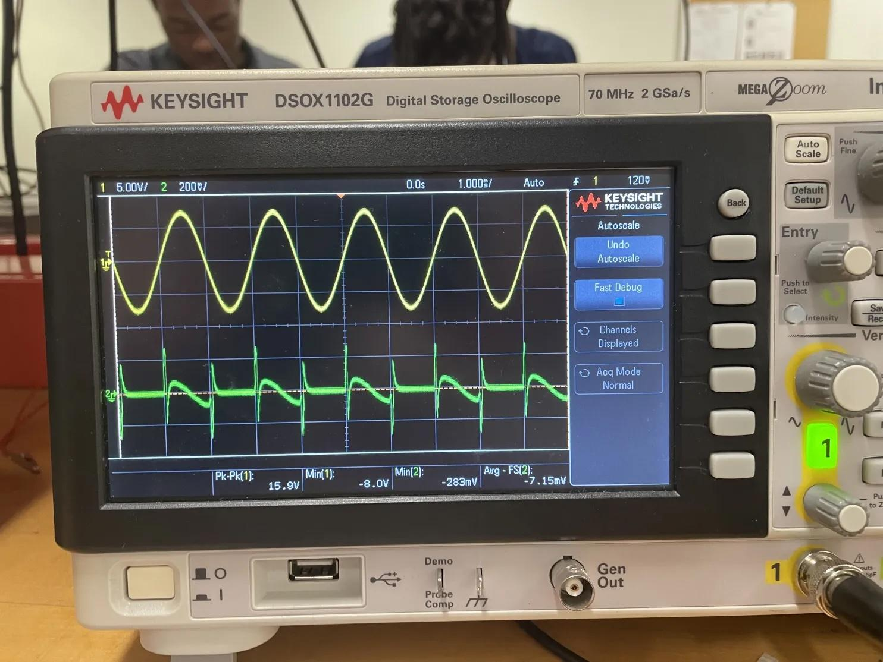
Vi (Yellow) and Vo (Green) for Figure 3b.

 | Vip-p(measured) | Vop-p(measured) | Gain  (derived from the measurement) | Gain  (from the prelab analysis) | Gain  (from the prelab simulation)
Fig.3a  (no buffer) | 16 | 1.8 | 0.1125 | 0.167 | 0.167
Fig.3b  (with buffer) | 16 | 0.566 | 0.0353 | 1 | 1

From the waveforms from Figures 3a and 3b, it can be observed that adding an op amp to figure 3a and a resistor R_{m} does not produce the same results. The gain from the two different circuits are entirely different values. Discrepancies between the pre-lab and in-lab could be a result of faulty equipment.
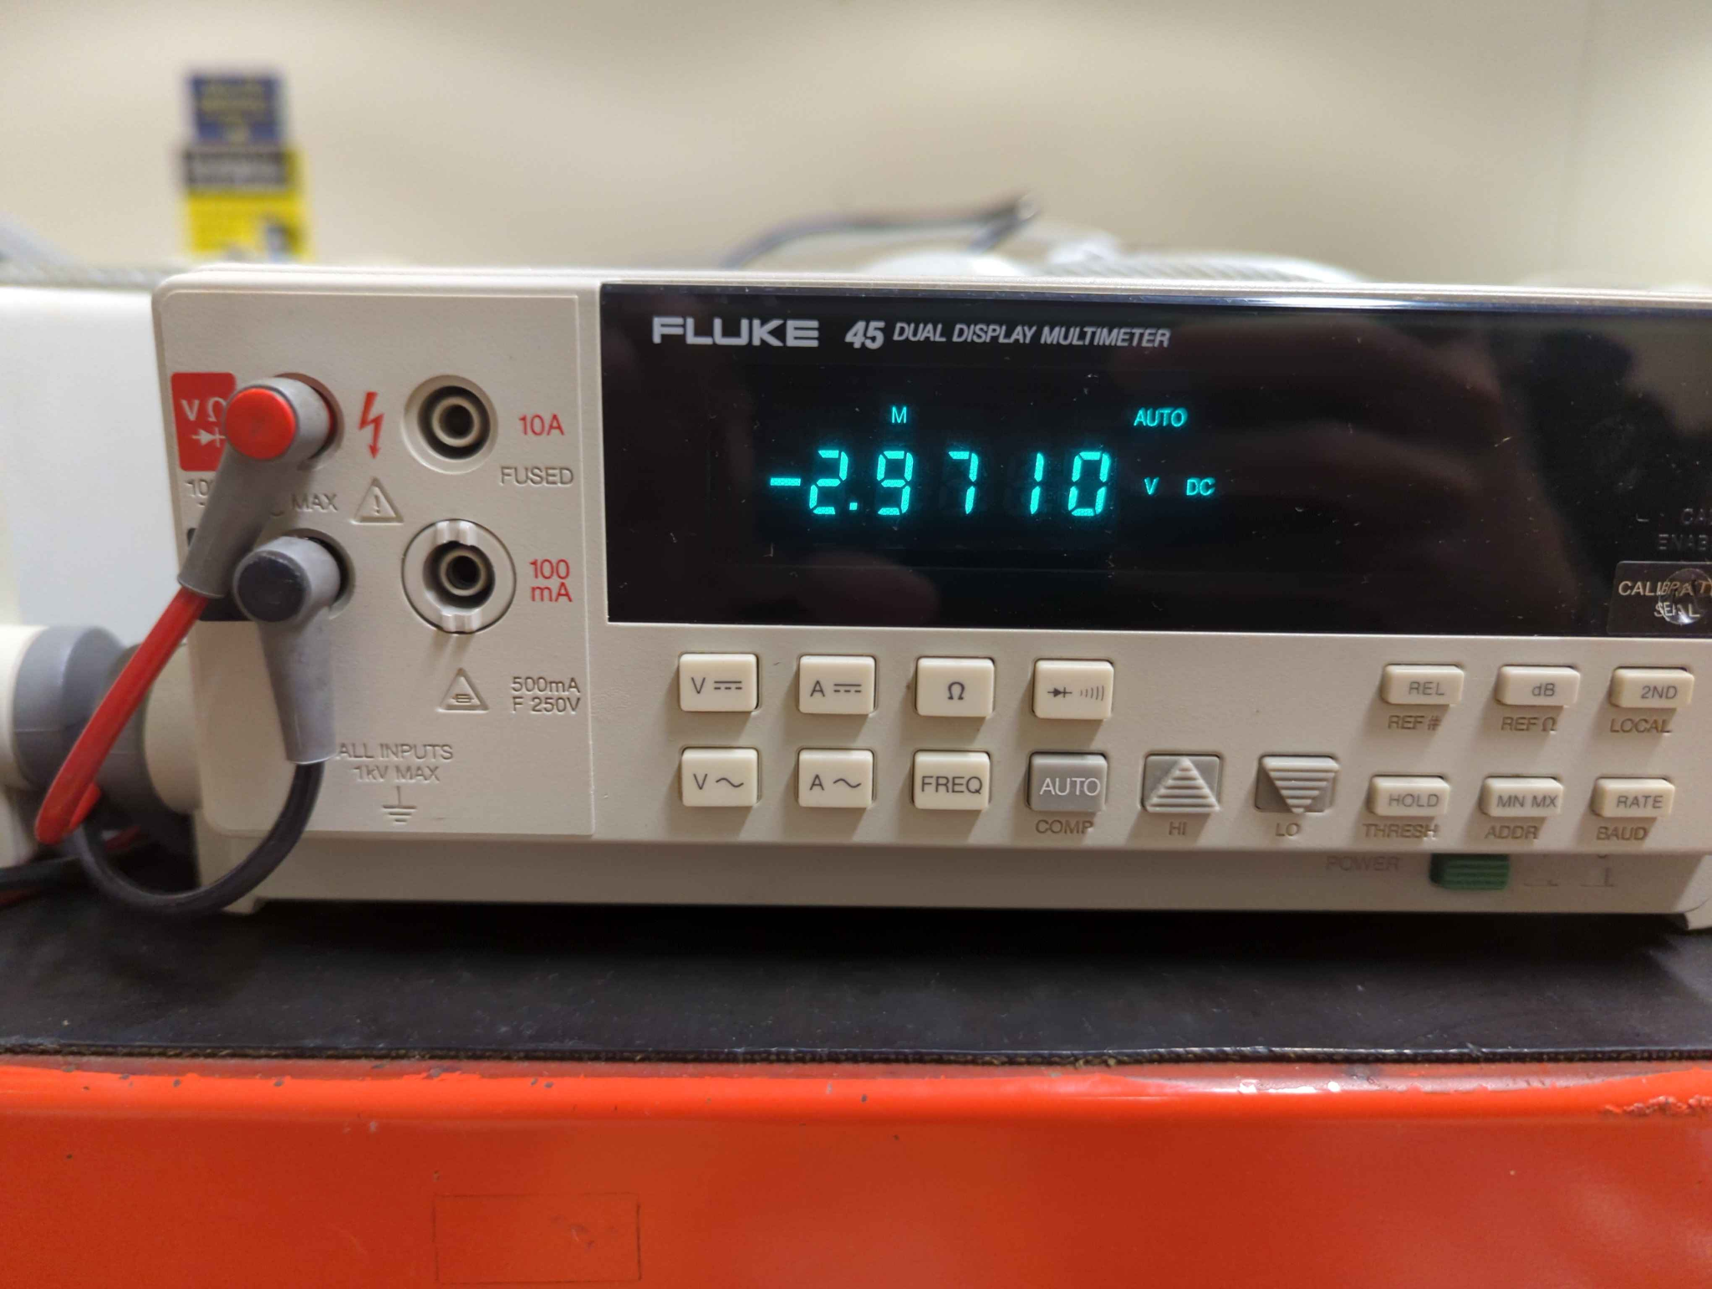
Switch S1 | Vc | Vo(analysis) | Vo(simulation) | Vo(measured)
Switch closed | 4 | -4 | -3.998 | -2.97
Switch open | 4 | 4 | 4.000 | 2.97

Closing and opening the switch S1 within the circuit creates a positive-negative inversion of the output voltage, V_{o}. This is from the circuit transitioning from an inverting to non-inverting amplifier and vice versa. It therefore can be observed that the circuit is functioning properly. The difference between theoretical and actual results can be from faulty equipment.

Conclusion and Remarks
This experiment provided valuable insights into the behavior of op-amp circuits, particularly in relation to feedback effects on output voltage. While most of our experimental results aligned with the pre-lab analysis and simulations, some discrepancies were observed, likely due to measurement inaccuracies and real-world non-idealities in the circuit. Despite these variations, the experiment effectively demonstrated the key principles of open loop and feedback mechanisms in op-amp configurations.

Appendix

References
Kassam, M. S. (2022). ELE504 Laboratory #1 [PDF]. D2L. https://courses.torontomu.ca/d2l/le/content/913319/viewContent/5864653/View

